Eric Teicholz SFP Scholarship Awardee Case Studies:
June 2024

- Bioenergy/Recycling Project, Nwiido Lekia, 2021 Awardee, Abuja Nigeria
The Facts

The decomposition of organic matter at landfill sites is one of the main causes of methane (CH₄) emissions released into the atmosphere, accounting for 5% of global greenhouse gas emissions. This powerful greenhouse gas has a global warming potential 86 times greater than CO₂ over 20 years. According to the IMF, methane has been responsible for about 30% of the rise in global temperatures since the beginning of the industrial era (1850-1900).
According to the World Bank, humanity produces nearly 2 billion tons of solid municipal waste (organic matter and other domestic waste, waste from offices, businesses, and building sites) every year. As the global population rises, this volume of waste is expected to grow by 70% by 2050.

Project Data
Developing Bioenergy/Recycling Park in Nigeria for Waste to Energy Project (WtE&R)

Objective
To harvest methane from dump sites as a renewable energy source to attain net zero emission from solid waste management.

Client: Rivers State Government
Investors: Rivers State Government, NNPC-New Energy Ltd, NDDC, TOTAL E&P and NEW MACPH ENVIRONMENTAL TECH LTD

Case study: Port Harcourt city & its environs is handling its solid waste business in a clean development mechanism approach to reduce GHG.

Our daily waste volume of 1505tons has the waste analysis characterization in line AsTm D5231-92

Organisms (biodegradable) 49.2%
Paper/cardboard 7%
Plastic (PET & HDPE) 19%
Plastic (PVC, HDPE, PP, PS, PE 4%
Construction waste (wood & metals) 2%
Garden trimming/fruit & vegetable 3%
Aluminum/cans 3%
Nylon/fabric 3.2%
Sand/cement 1.5%
Sewage disposal 5.8%

PH & ts environs has a population of 1,980,000 million people with 1.1kg/capita daily waste generated rate. Our waste collection strategy is handled via the following approach
- Bring point
- Door to door
- Civic amenities
- Deposit or refund

Information has been given to 2 American companies to produce a compelling concept note/ and investment details required in turning our cost of managing solid waste into a generating revenue source. A lot of recycling companies exist in-country for use of space within the acquired park to handle various recyclables is already attracting patronage all over Nigeria.

Parameter for estimating CH₄ emission from solid waste collection in PH
Parameters | Value | Unit
Waste collected | 549,325 | t/u
Putrecibles for methane conversion | 0.525 | Tons/biodegradable
CH4 fraction in biogas | 68 | m³/ton
CH4 density | 0.00071 | Tons CH₄/m³- CH₄
GWP - CH₄ | 28

Using the above value CH₄ emission is 389,865 tons eq/year

GHG emissions due to fossil consumption are as follows
Parameters | Value | Unit
Own electricity demand | 3000 | Mwh/year
Emission factor of Co2 | 1 | Kg co2/kwh

The project GHG emission and net emission reduction if the entire gas produced is used to generate electricity.
Emission avoidance (kg co2/yr)
Gross electricity generation – own use x emission factor
Parameters | Value | Unit
Methane Derived | 13928 | Tons CH₄ r/y
Heat value CH₄ | 55,400 | MJ/ton CH4
Conversion coefficient from heat to electricity | .3
Power generation efficiency | 0.33 | Kwh/MJ
Electricity supply | 76,389 | Mwh/year

Emission reduction = CH₄ recovery + fossil fuel avoidance – project GHG emission

Where Ch4 recovery = 389,865tons co2/yr
Fuel avoidance = 73,389tons co2/yr
Project GHG emission = 0 tons co2/yr

Using the above the net emission reduction can reach = 463,254tons co2/yr

Revenue – N5,181,852,000 for N68/kwh unit of electricity sales


2. Waste Recycling at Ecobank Sheila Cofie, 2023 Awardee, Ghana

IRENE SHEILA COFIE-CASE STUDY
I am Irene Sheila Cofie a Facility Manager at one of the leading Banks in Ghana called Ecobank Ghana PLC. Am also the deputy Manager for the Ecobank Business Services comprising the following Units: Facility Management Unit, Procurement Unit, Protocol Unit, Realty Unit, Transport Unit, Records Management Unit and Corporate Security Unit and I hold a Facility Management Professional certification and Occupational Health and Safety certification from UK.

The knowledge I received from the Sustainability facility professional training was very helpful. I currently part of the Sustainability Taskforce Committee who planned the sustainability week celebration in my organization, focusing on Waste Transformation. Some of the activities planned were the launching of the sustainability week, the Green Idea challenge, eat Green day, Staff Webinar on waste management as well as donation of recycled materials to a Senior Secondary School. I liaised with the various companies that were into recycling and agreed on the recycled items to be donated to the school, I was also part of the team that sensitized staff on the importance of sustainability practices.

The sustainability week launch program was held by my organization on the 18th of March,2024 where there was a welcome address by our Managing Director, keynote message by UN Global Compacted and the Central bank Governor, as well as a panel discussion on the Theme, Uniting forces for Waste Transformation. The role of the Public and Private sectors. During the launch, we also highlighted on key sustainability achievement like the EDGE certification, Environmental Business practices like waste management amongst others.

All staff were sensitized on the importance of waste transformation and as such sustainability pledge placards were placed at vantage points at our Ecobank Head Office building where staff endorsed their commitment to the sustainability goals set by the bank as per attached pictures. The Green Idea challenge made staff unleash protentional on innovative ways to recycle the waste that the Bank generated. This Green idea was reviewed by Judges from Water, Energy and Recycled Companies and staff were awarded for their ideas as accordingly. Ecobank Ghana Limited as part of our Corporate social Responsibility donated 1,500 recycled exercise books,13 upcycled car trye washing hand basins and 20 dustbins to St Paul’s Senior High School (SPACO), a high school with a population of 1,500 students. The Banks partner Zoom lion Ghana Limited, educated the students on sustainability and launched the SPACO Branch of Zoom Lion ambassadors. These Zoom lion ambassadors 20 in numbers were trained to carry out sustainability initiatives and impact on others.

GALLERY

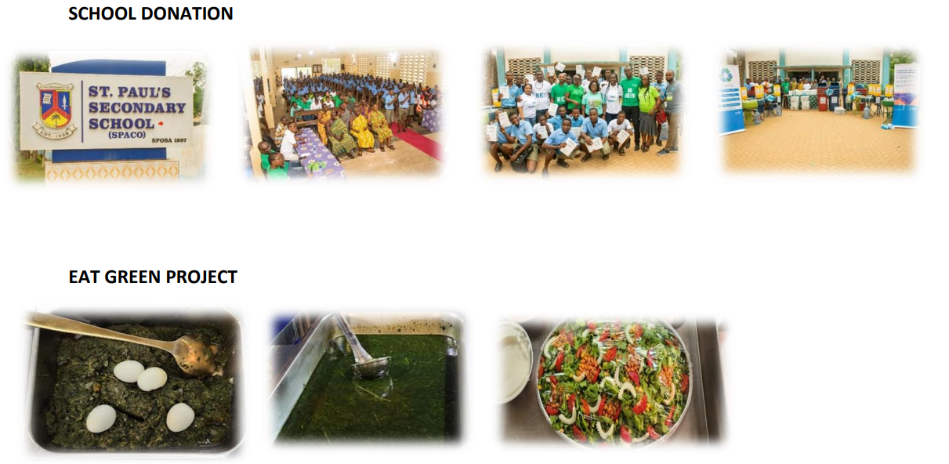

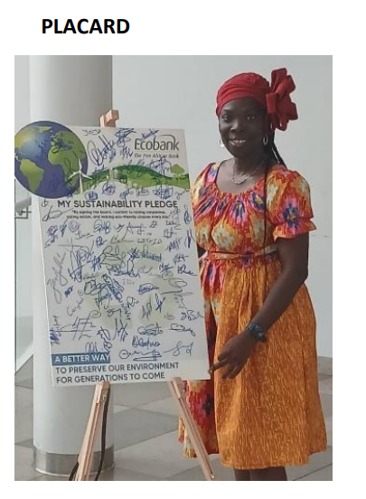

3. Reusable Filter Conversion
Kaylee WSilson, 2003 Awardee
USA

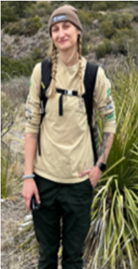

Awardee

Name of ET SFP Awardee | Kaylee Wilson
SFP Status | Complete

Project Data

Case Study Name | Bouldering Project x K&N reusable filter conversion
Date | 5/22/24
Client | Bouldering Project LLC.
Case Study Description (as it relates to sustainability) | Project overview: Transition from Single-Use to Reusable Air Filters.  In an effort to advance sustainability practices and improve operational efficiency, Bouldering Project is teaming up with K&N to implement reusable air filters in our HVAC systems nationwide. This initiative will eliminate the waste produced by single-use air filters, reduce overall costs, and improve the efficiency of the rooftop units.
Status of the project | In Progress.
Goals and Objectives | The primary goal of this project is to enhance the sustainability and operational efficiency of our building’s HVAC systems. By transitioning from single-use air filters to K&N reusable air filters. This transition aims to divert filter waste, reduce costs, and improve the HVAC systems performance.  - Divert waste from landfill:  - Target: reduce the number of single-use filters disposed annually by 100%  - Actions: Implement

reusable filters across all rooftop and preliminary units, establish routine cleaning and maintenance schedule for these filters, and educate staff on proper filter handling and maintenance.
- Save Money:
  - Target: ROI in 12 months
  - Actions: Conduct a cost benefit analysis comparing the average cost of
single-use filters versus the reusable filters including, initial investment, useful life, and replacement costs. Monitor and track the financial savings
year-over-year.
- Enhance efficiency of rooftop units.
  - Conduct regular performance assessments and efficiency tests to ensure filters are contributing to improved airflow.

By focusing on these objectives, this project aims to provide both environmental and economic benefits while ensuring the HVAC systems operate at optimal efficiency. This approach aligns with our broader commitment to sustainability and operational excellence.

Case Study Support Material

Testimonials | We have been very satisfied with the ease of transition.
Illustrations | (Full case study from K&N HERE)

Results

SFP Awardee testimonial | As a sustainability facilities professional and the National Facilities Manager of Bouldering Project I am dedicated to implementing practices that promote environmental stewardship and operational efficiency.  By adopting reusable air filters in all of our locations we have significantly reduced our landfill waste, contributing to a cleaner environment. This initiative aligns with the principles of the SFP certification which emphasizes sustainable facilities management and resource conservation. The cost savings and improved efficiency of our HVAC system further highlight the full benefits of this initiative.  We are proud to lead by example in the climbing industry. Showcasing how sustainability initiatives can drive environmental, social, and economic gains.  -Kaylee Wilson, National Facilities Manager: Bouldering Project

GLOBAL BETTER PERFORMANCE.
FILTRATION BETTER FOR THE ENVIRONMENT.
BETTER FOR YOUR BOTTOM LINE.

CASE STUDY: BOULDERING PROJECT
PARTNERING WITH A LEADING CLIMBING GYM AND FITNESS CENTER TO REDUCE ANNUAL FILTER WASTE BY 15 TONS.

THE FILTRATION CHALLENGE AT BOULDERING PROJECT
The Bouldering Project, headquartered in Seattle with 12 locations nationwide, is a nationally recognized indoor bouldering gym where climbing enthusiasts go to climb, train, exercise, and practice yoga. Their facilities are typically located in densely populated urban environments, with high occupancy at peak hours creating a significant amount of chalk dust that must be filtered efficiently and effectively to maintain a safe and pleasant experience for climbers.
At Bouldering Project’s small facilities, the number of filters needed per replacement cycle could be as few as 6 in the RTU for the building. In contrast, larger facilities, like the Springdale gym in Austin, 11 RTU’s continuously run to keep the building cool and over 60 filters keep customers breathing easy with clean air.
Bouldering Project’s filtration challenge is unique in that the volume of particulate they are filtering is massive — enough to be measured in kilograms per day — and the frequency with which they change filters to maintain an enjoyable experience for members is very high — up to 2 times a week in the driest and dustiest times of year.








































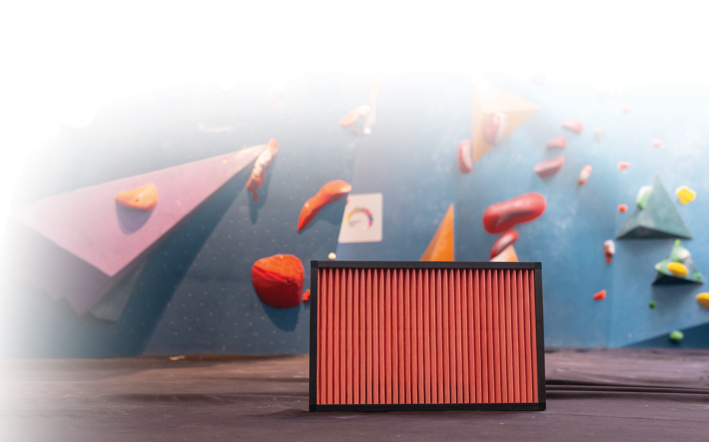
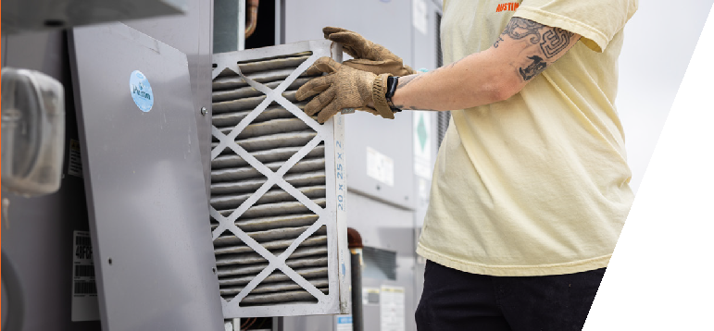
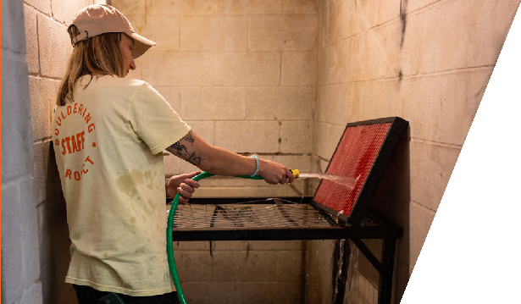
Sustainability has three components:

“
“
“

Economic, Environmental and Social — This makes sense for us on the Economic side because we’ll see payback in less than 12 months. On the Environmental front, we are removing 15 tons of waste from the landfill every year. And on the social side, we are helping create a better experience for the members of the community that use our space. Ticks all the boxes”

K&N ENGINEERING

1455 CITRUS ST.

RIVERSIDE, CA 92507

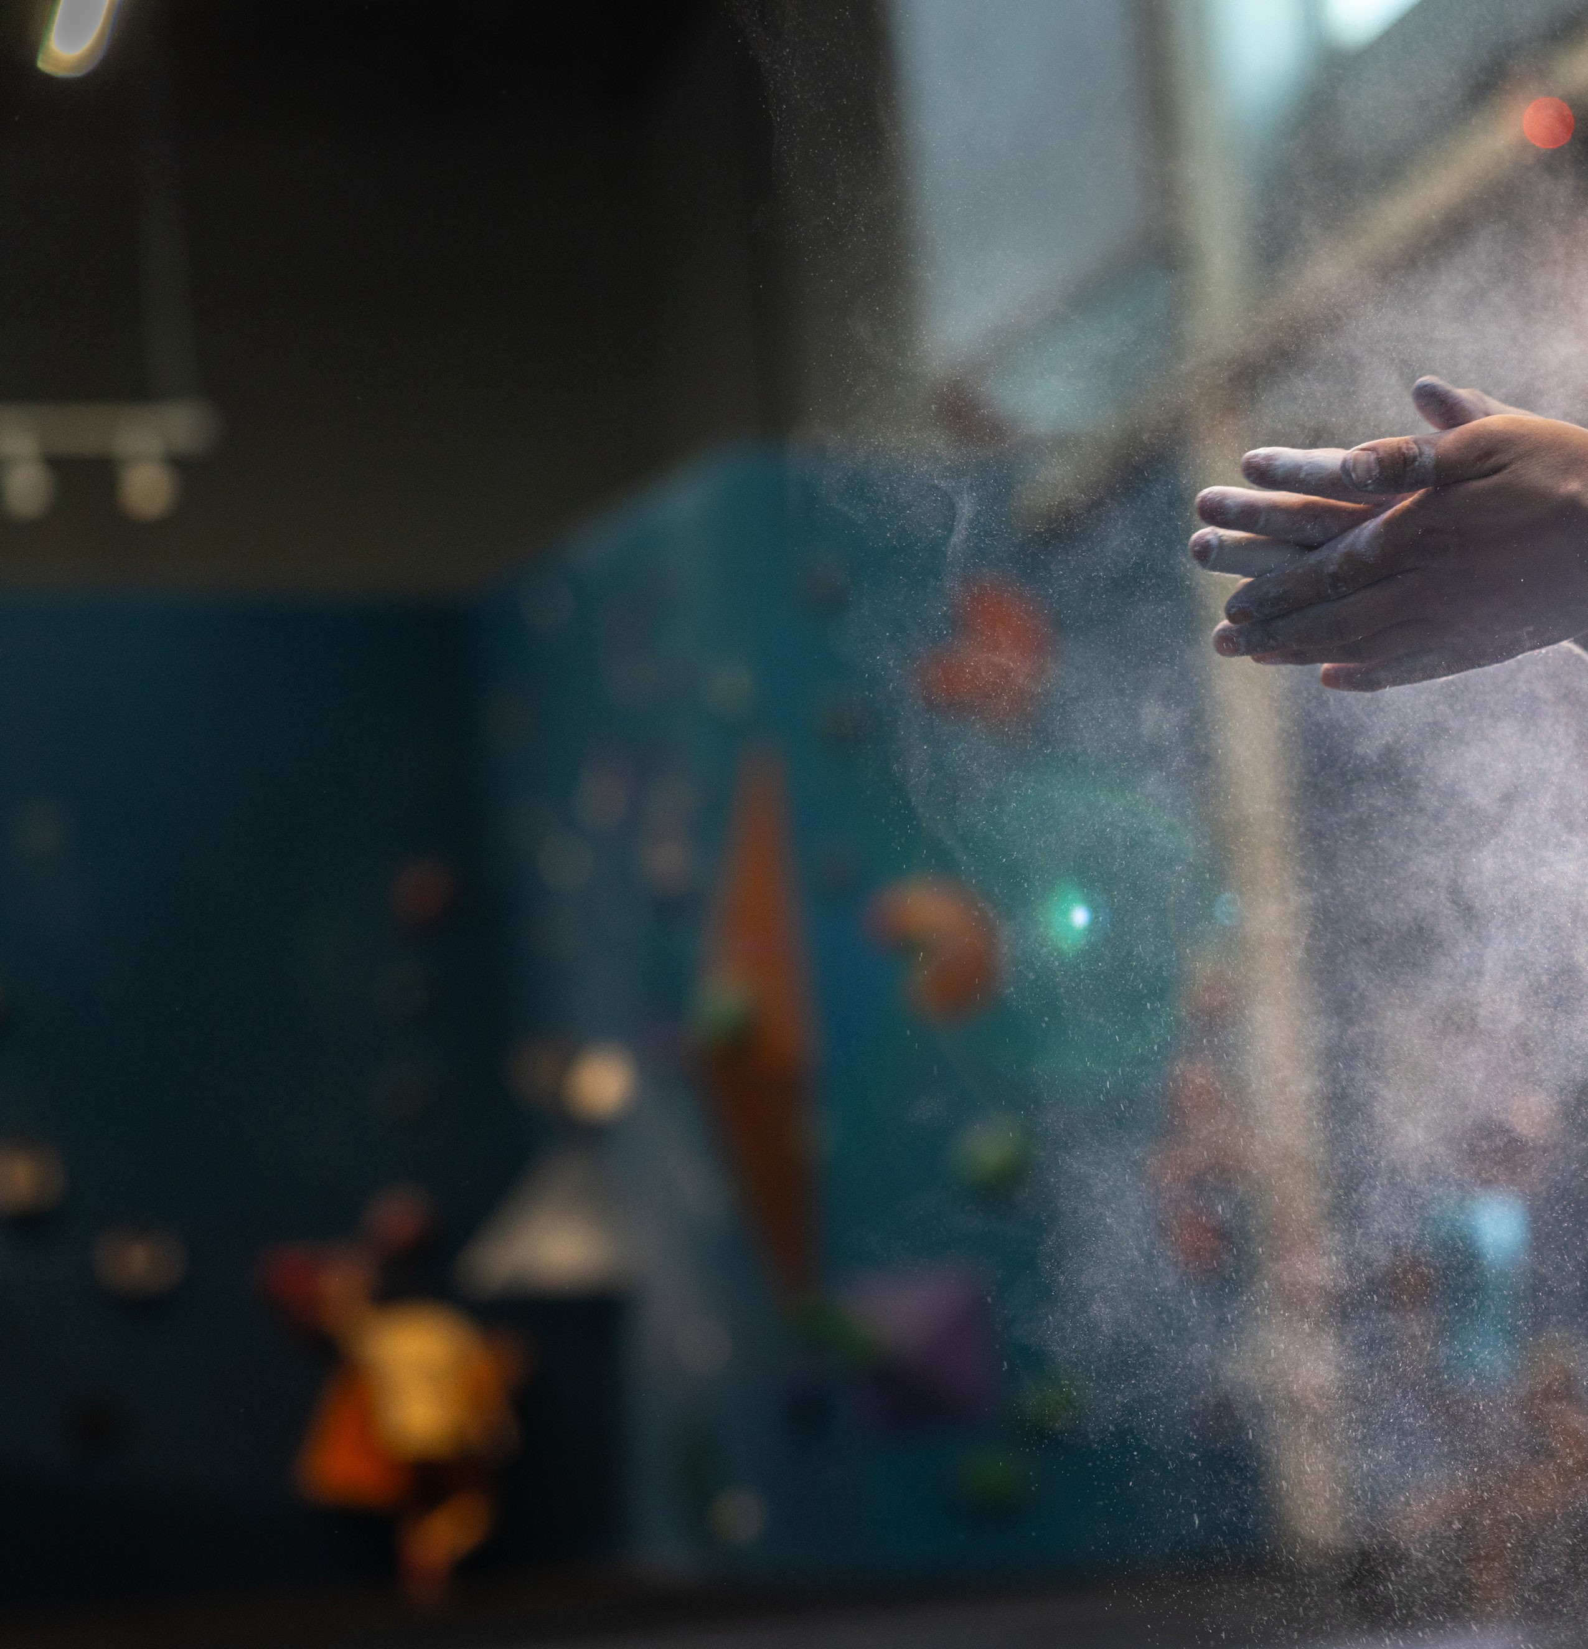
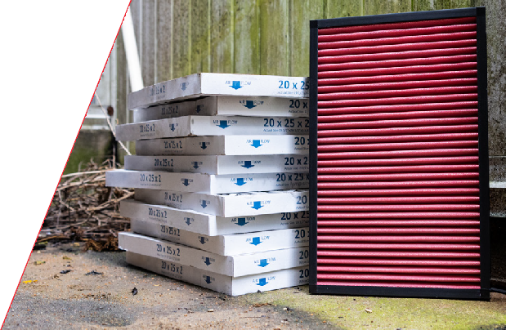

GLOBAL BETTER PERFORMANCE.
FILTRATION BETTER FOR THE ENVIRONMENT.
BETTER FOR YOUR BOTTOM LINE.

PROBLEM:

Until 2024, the Bouldering Project filtered their air the same as any other company: by purchasing and replacing legacy single-use filters and disposing of them in the landfill. The process racked up sizeable operational expenses as Bouldering Project continuously purchased filters to replace the old ones. In fact, in 2023 Bouldering Project purchased and disposed of over 14,000 filters at an average cost of about $10 per filter, generating about 15 tons of mass to landfill and about $150,000 off their bottom line.
As a company that prides itself as being a responsible participant in the climbing community, Bouldering Project recognized that their large contribution of mass to the landfill was unacceptable. Bouldering Project prides itself on it’s superior gym experience, continuously investing to improve the overall gym experience at their facilities — $150,000 per year is money that would be well spent to better the experience and facilities and provide more community support.
SOLUTION:

K&N’s High-Flow Washable Filters are and were the perfect solution to help reduce Bouldering Project’s operational expenses and minimize their impact to the landfill. Starting with a small PILOT of 6 filters, in one air handler at a single facility, K&N was able to demonstrate equal/or better filtration with their washable reusable product.
Bouldering Project facility managers integrated the filter washing process into their existing workflows and the PILOT yielded immediate savings on filter purchases at the facility. The PILOT expanded to a larger facility with consistent results as the pilot scaled and in the spring of 2024 Bouldering Project rolled out K&N Washable HVAC filters to all their facilities nationwide.

KEY RESULTS:
Investment Payback
- Payback Period: Less than 12 Months
Long Term Savings
- 5 Year Estimated Savings: $500,000
Waste Diversion
- Annual Waste Diversion of 14,000 Filters (15 Tons)

Passionate about sustainability? Let’s talk: nowaste@knfilters

K&N ENGINEERING

1455 CITRUS ST.

RIVERSIDE, CA 92507

